07DEC2019

Project 2: NHL Stats Project Proposal

Scope:

* Screen shot of meta data (what columns mean)
* ¾ screenshots inspiring visualizations
* Sketch of final design
* Link to primary github

The scope of our project was inspired by previous research on the birthdate effect in higher level and professional sports. The birthdate effect is a trend observed by social workers and psychologists as a relationship between birthdate and academic or athletic success. The trend shows that based on the marker for achievement, being born at a select time of year can be a benefit or hinderance. For sports, mental maturity as well as physical size are advantageous toward athletic success. The NCAA reported on their website that a correlation can be found in the proportion of student athletes with birth dates at specific times of the year and success in their chosen sports (<http://www.ncaa.org/about/resources/research/birthday-effect-college-athletics>). Male athletes born in the beginning of the calendar year represent a large proportion of NCAA athletes in ice hockey and tennis. However, a large proportion of male athletes in basketball, baseball, football, and soccer have birthdays around the beginning of the school calendar. This observation was further studied in Malcom Gladwell’s novel, Outliers: The Story of Success. In the novel, Gladwell discusses the observation that a large proportion of Canadian hockey players in the National Hockey League have birth dates in the beginning of the calendar year.

In this study, we wanted to further these studies by determining if this trend was true for NHL players of other nationalities. We also wanted to determine if birthdates at the beginning of the calendar year correlated with a higher success rate when the athlete makes it into the NHL. Based on Gladwell’s study, there are many successful outliers to the trend. We defined success as number of games played, career total for goals, and career total for assists.

Our data came from a Kaggle source (<https://www.kaggle.com/martinellis/nhl-game-data#table_relationships.JPG>), which ultilized several csv files to develop an SQL database. Of these csv files, we utilized four to create our own SQL database: “player_info.csv”, “game.csv”, “game_skater_stats.csv”, and “game_goalie_stats.csv”. The web source included a useful ERD displaying how the data sets were connected.

Image 1: ERD included with the data files on Kaggel.

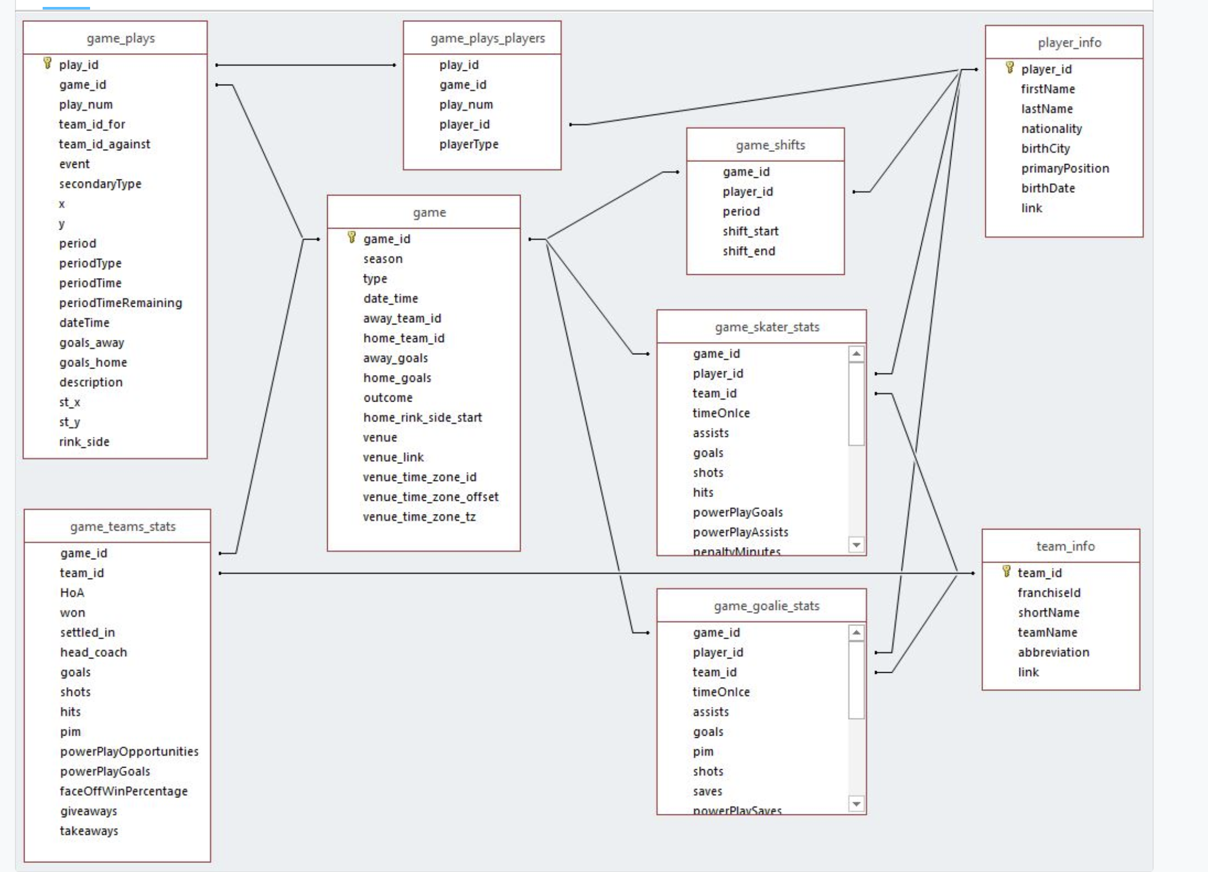

(include explanation of table headers)

Player birthdate vs. count scatter plot that can be sorted by Nation of origin of players in nhl x- 1999 birthdates

Markers of success (# of games, goals, assists, points) selectable by Nation

To see if the trend in early birth years being a marker of entry into the NHL existed only in Canada and the United States or also in other nations with players in the NHL

We wanted to see if birth year correlated to success in the NHL regardless of national origin

If birth date correlates to getting into NHL, does it correlate to a successful career

(hold for scatter plot example) x= birthdate, y= count, selector = nation

Hold for (histogram example) x= birthdate, count= games played, goals, assists, points, y= counts, selector =nation

<https://github.com/gwathen2019/Project2_NHL_stats>

Project Requirements:

* RESTful Flask App (provides the visualization to the host) **Gabbie**
* HTML/CSS **Greg**
* JavaScript **Clay**
* JS Library not used in class **Clay**
* At least one DB (SQL w/ Postgress) **Clay**
* A dashboard page w/ multiple charts that update from same data source ALL
* Plotly (scatter plot and histogram) **Megan**
* Data contains at least 100 entries ALL
* User Interaction: menus, dropdowns, textbox (included in our chart design) ALL
* At least three views ALL
* Proposal write up **Gabbie**
* Presentation Format/Set up ALL

Additional Opportunities:

If time permits, other points of interest:

* GeoMap of player origins **Greg**
* Add a chart of the top 10 outliers (late birth, high success) **Gabbie?**
* Most successful hall of famers vs birth date
* Web scrap other source for data **Clay?**
* Use to predict the success of current players
* Additional point of success: salary, playoff games played, Stanley cup rings **Gabbie?**
* Alternative chart types **Megan?**
* Look to adding plus/minus as a measure of success **Gabbie?**